

**PROPOSAL FOR PROJECT DEVELOPMENT**

**INFO 4302**

**SECTION 1**

**PROJECT TITLE**

**BOOK REVIEW APPLICATION**

**GROUP**

**ASIAH**

|  |  |
| --- | --- |
| **NAMES** | **MATRIC NO** |
| **ADILAH SYAHIDAH BT DANIAL** | **1623014** |
| **AFIFAH BT AHMAD** | **1624346** |
| **MAZLIN ANIS BT MOHD ZAHARI** | **1623514** |

**1.1 INTRODUCTION**

The application that we want to develop is a book review application. It is a platform for people to share their reviews, thoughts and comments on books that they have read. Authors can upload pictures of the book with the title, write a review and state a rating for the book. Authors can view others’ review on the application too.

**1.2 PROBLEM STATEMENT**

The application that we will develop is a mobile application. The authors are book enthusiasts that want to share their opinion on books that they have read and for people who want to look for online book review. Currently, people only share book reviews on social media or through acquaintance. This platform will allow users to share their opinions and reviews with a broad audience.

**1.3 PROJECT OBJECTIVE**

The objective of the project is to gather all book lovers to share their interest in the same platform. Authors can read book reviews that are written by other authors to get feedback from the readers. Readers can search for a list of books that have been reviewed by other readers. The report that will be produced is the overall report about the project in written form.

**1.4 PROJECT SCOPE**

**1.4.1 Scope**

This application is covering book review only. This mobile application is ready to use by all group of people especially book enthusiasts. This project consists of the star rating and review from the authors thus readers can acquire the details of the books.

**1.4.2 Targeted User**

Our targeted user is book enthusiasts.

**1.5 CONSTRAINTS**

Throughout this project, we have experienced the time constraints as our main challenges in developing this project. We also encounter difficulties in coding as we are not skilled enough in this area thus we find it hard for us to fulfill this project in time.

**1.6 FEATURES & FUNCTIONALITIES**

In this book review application, the main features of this application is authors can write reviews for any books that they have read before. The reviews of the books can be consist of the experiences, summary, emotions and many other things that can be related to other readers to generally know the content of the book.

Furthermore, authors can rate the content of the book by giving stars to it. The best content will have five stars. Before the readers start to read the overview of a book, they can check the given rating as the simplest way to know other people’s interest and thought about the book. Thus, readers can read the review to know more about the book if they are interested to read it.

This book application review also provide a list of books that have been read by the authors. Readers can check the book list to search for any books they want to read. Readers can get to know many books that are out of their common genre books.

**1.7 SIGNIFICANCE OF THE PROJECT**

This book review application can help readers to save their time as it will help the potential readers to get an overview of the book’s content. Readers can determine whether the book is suitable for them to read or not. In addition, book review app can influence many people to read the particular book. For example, when the rate of a book is good, people tend to read the book because of the curiosity and the storyline of the book.

Other than that, with the presence of this book review app, it will help to validate the worthiness of a book. The higher the rating, the worthier the book is. This situation will lead to many readers to join reading the particular books.

As for the authors, higher rating shows that the content of the books is good and can attract more readers. It will lead to the growth of sales of the books. If readers love to read a book that has been reviewed by the authors,it will increase the motivation for the authors to write reviews of any books with a greater content.

**1.8 SCREEN NAVIGATION & COMPONENTS**

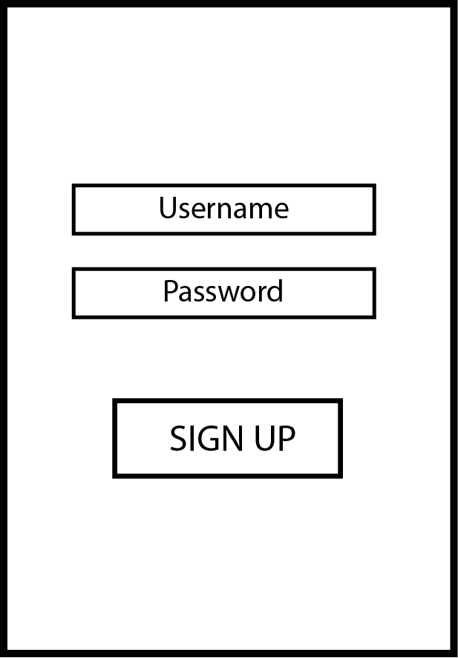 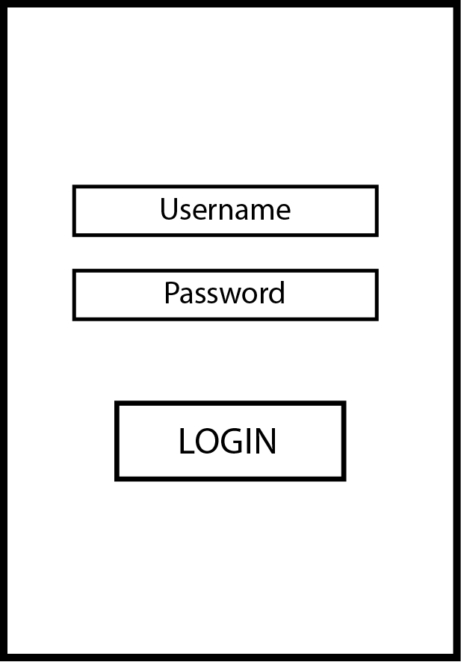 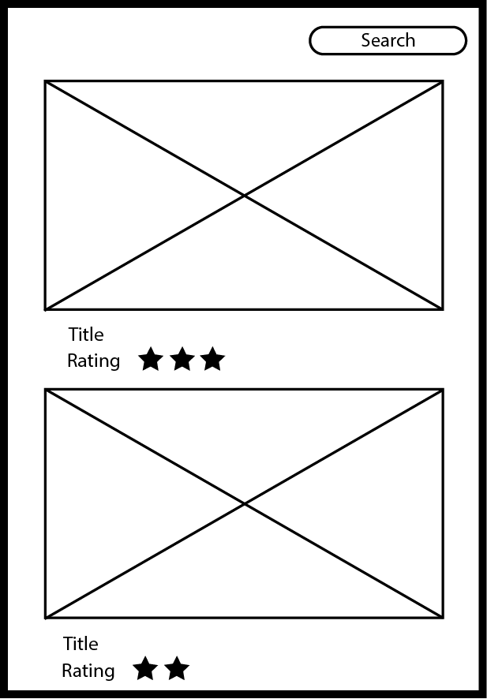 Sign up page Log in page Homepage

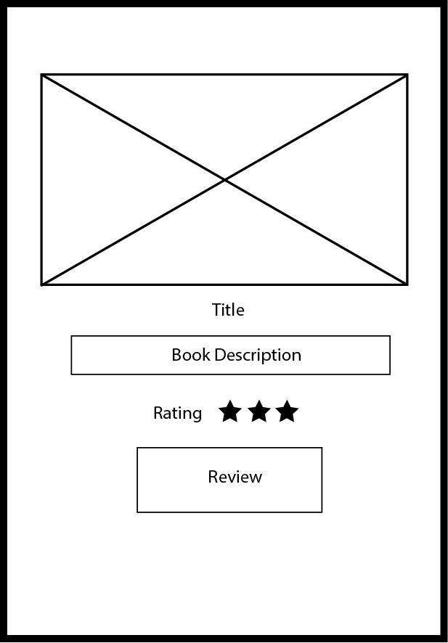 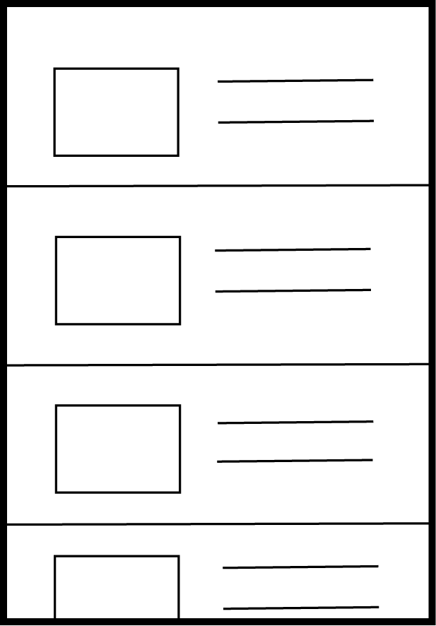 Book review page List of books page

**1.8 SEQUENCE DIAGRAM**

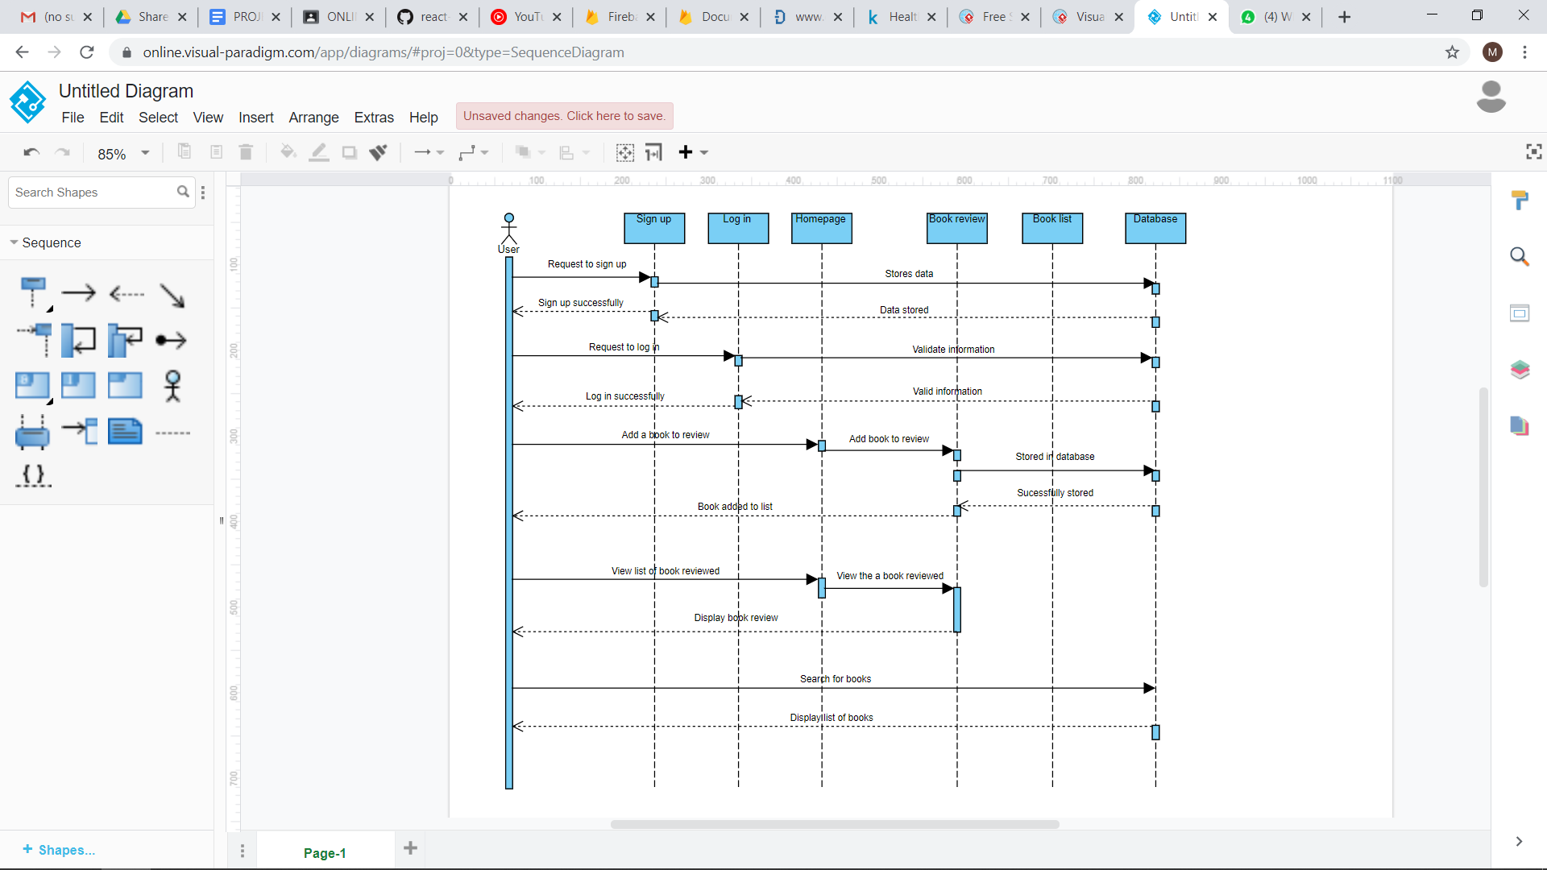

**1.8 SUMMARY**

Book review application is an application that is to developed to allow teh authors to share their review, overview and thoughts about a book that have read. It also allows the authors to rate the books depending on their preferences. This book review application has three main features which are book review, rating and search and list of books available. This application is targeted for book enthusiasts. The benefit of this application is that it will help readers to search for books that they intended to read. In conclusion, this book review application can ease the book enthusiasts because they can acquire information of the book in a simple application.

**1.9 REFERENCES**

The Apps You Need To Actually Buy, Read, & Review Books On Your Phone. (n.d.). Retrieved from <https://www.bustle.com/p/9-book-apps-that-make-buying-reading-reviewing-books-so-much-easier-4026676>.

Codepath. (2015, February 17). codepath/android-booksearch-demo. Retrieved from <https://github.com/codepath/android-booksearch-demo>.